SC4 Transcript Requests
At the end of each semester, you will need to have SC4 send your transcripts to the college you plan on attending so that you do not need to retake your courses again.

In order to do that, follow these simple steps online, using your Portal:

- Log into the SC4 Portal using your username and password. Username is your first initial and last name (ex. thessling) and your password is the last 6 digits of your social security # unless you have changed it already.

- Once you are logged in, on the right side, click on “College Credit Students”.
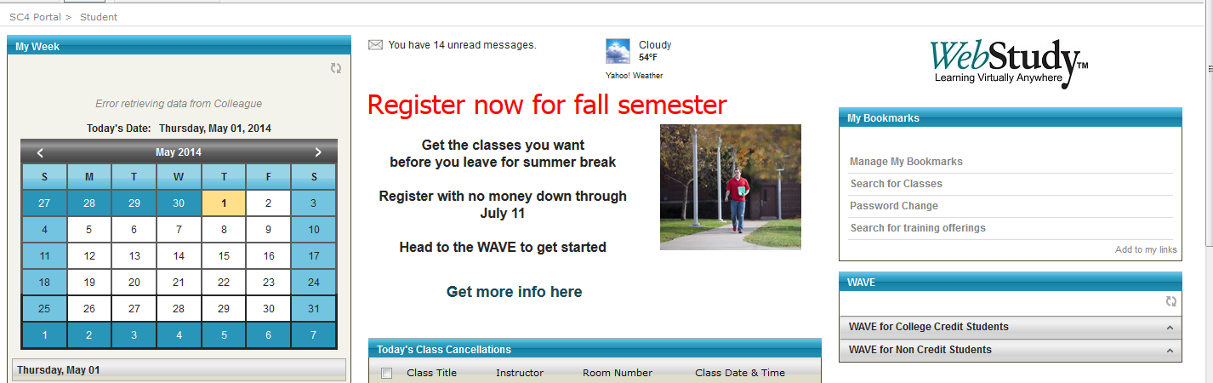

- Click on “academic profile”.

- Click on “transcript request”.
- Your address will already appear. You can check the box to have a copy sent to your house for your records (optional).

- Enter the address of the school you plan to attend so they can send your transcript there. Address it to the college name: Office of the Registrar
Check this box if you also want a copy sent to your home for your records.
School’s address – google it if you do not know it.

- Choose “official college transcript” in the dropdown box.

- Click the “submit” button. You can track their progress using the Portal, but they should be sent to the college within 7 business days.

